**Karan Arora**  **R.L. Institute M: 9416974837**

**Max Time : 1 hr** **Class = 9th Science Test Max Marks : 25**

**MOTION**

[Graphs , Equations of Motion , Uniform Circular motion]

1. Multiple choice questions : [ 1 X 5 = 5]
2. The velocity time graph of a body is a straight line with negative slope. It implies that :

|  |  |  |  |
| --- | --- | --- | --- |
| a) velocity is uniform | b) velocity is zero | c) a = positive | d) a = negative |

1. If the displacement -time graph of a particle is parallel to the time axis, the velocity of the particle is :

|  |  |  |  |
| --- | --- | --- | --- |
| a) unity | b) infinity | c) zero | d) none of these |

1. Their distance versus time graphs are shown in figure. Choose the correct statement:

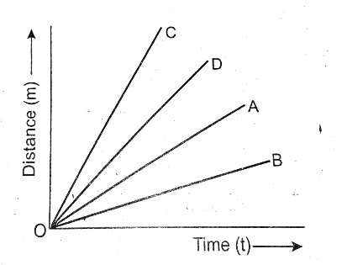

|  |  |
| --- | --- |
| a) Car A is faster than car D | b) Car B is the slowest |
| c) Car D is faster than car C | d) Car C is the slowest |

1. The velocity time graph of a body is straight line parallel to time axis, the acceleration of the body is :

|  |  |  |  |
| --- | --- | --- | --- |
| a) positive | b) negative | c) zero | d) none of these |

1. A body starting from rest acquires a velocity of 10 m/s in 5 seconds. The acceleration of the body is :

|  |  |  |  |
| --- | --- | --- | --- |
| a) 10 m/s2 | b) 5 m/s2 | c) 2 m/s2 | d) none of these |

1. When is the acceleration taken as negative? [ 1 ]
2. What is uniform acceleration? [ 1 ]
3. What is the simplest type of motion? [ 1 ]
4. Can a body have constant speed but variable velocity? [ 1 ]
5. What can you say about the motion of an object if its speed time graph is straight line parallel to time axis? [ 1 ]
6. A bus starting from rest moves with a uniform acceleration of 0.1 m/s2 for 2 minutes. Find : [ 2 ]

(a) The speed acquired (b) The distance travelled.

1. The length of second hand of a clock is 14 cm. Calculate its speed. [ 2 ]
2. The brakes applied to a car produce an acceleration of 6 m/s2 in the opposite direction to the motion. If the car takes 2 second to stop after the application of brakes. Calculate the distance travelled during this time. [ 2 ]
3. A car acquires a velocity of 54 Km/h in 10 seconds starting from the rest. Find : [ 3 ]

(a) The acceleration (b) The average velocity (c) The distance travelled in this time.

1. A stone is thrown in a vertically upward direction with a velocity of 5 m/s. If the acceleration of the stone during its motion is 10 m/s2 in the downward direction, what will be the height attained by the stones and how much time will it take to reach there? [ 3 ]
2. Draw the v-t graph that indicates : [ 3 ]

(a) uniform acceleration when initial velocity is not zero. (b) Increasing accelerated motion